http://www.jstor.org
The Life, Writings and Art of Vasiliy Chekrygin
Author(s): E. A. Nekrasova
Source: Leonardo, Vol. 17, No. 2, (1984), pp. 119-123
Published by: The MIT Press
Stable URL: http://www.jstor.org/stable/1575001
Accessed: 15/05/2008 09:27
Publisher contact information may be obtained at http://www.jstor.org/action/showPublisher?publisherCode=mitpress.

JSTOR is a not-for-profit organization founded in 1995 to build trusted digital archives for scholarship. We enable the scholarly community to preserve their work and the materials they rely upon, and to build a common research platform that promotes the discovery and use of these resources.
For more information about JSTOR, please contact support@jstor.org.

Leonardo Vol. 17, No. 2, pp. 119-123, 1984. 0024-094X/84 $3.00 + 0.00.
Printed in Great Britain. Pergamon Press Ltd

THE LIFE, WRITINGS AND ART OF
VASILIY CHEKRYGIN
E. A. Nekrasova

Teacher, Art History Department, Moscow University,
Lomonosov Prospect 14, Flat 498, 117296 Moscow, U.S.S.R.
Abstract -Vasiliy Chekrygin (1897-1922), friend of the futurist poets Mayakovsky and Khlebnikov, became skeptical of futurism and all the other 'isms' dominating European and Russian art at the time of the First World War and the Russian Revolution. In his fragmentary and truncated career he tried to preach and practice a 'synthetic' art capable of objective expression of reality and, through the journal Makovets, appealed for a return to Goethe's harmonious attitude to the arts and sciences. Art works shown here include sketches for a huge unrealized mural on 'The Resurrection' which, following the thinking of nineteenth-century philosopher Fedorov, Chekrygin conceived of in terms of the Colonization of the Cosmos by an enlightened and transformed humanity. In this article, E. A. Nekrasova gives a brief account of Chekrygin's life and work by way of introduction to some of the artist's own written statements.
(Received 10 September 1982)

INTRODUCTION

The Russian artist Vasiliy Chekrygin occupies a unique place in Soviet art of the twenties.
Chekrygin was born January 1897 in Kiev, one of many children in a poor family. He began to draw at the age of six. His first impression of visual art came from the mosaics in the Kievan Cathedral of St Sophia, where he made many drawings. Of these earliest drawings, only a portrait of one of the monastery's servants survives.
In 1910 Chekrygin entered the Moscow School of Painting, Sculpture and Architecture. Here his exceptional talents won him a Levitan scholarship. During this period he made friends with the poet Vladimir Mayakovsky, also a student at the school. In 1913 Mayakovsky 'published' a collection 'I', with lithography handwritten text and illustrations by Chekrygin, in cooperation with L. F. Zhegin [1]. In the winter of 1913-1914, Chekrygin exhibited "a portrait in the style of El Greco and Cezanne" at the XXXV student exhibition of the Moscow School of Painting, Sculpture and Architecture. Early in 1914 he met Mikhail Larionov, whose work he much admired. In his turn, Larionov formed a great affection for "Vasen'ka" (the diminutive of Vasiliy) and called him a "visionary". Chekrygin exhibited with the futurists, rayonists and primitivists at 'Exhibition No. 4,' organized by Larionov in Moscow in 1914.
When Chekrygin had completed his studies, he and his friend Zhegin went abroad. From April to September of 1914 they visited Munich, Vienna, Paris, and the south of France near the Spanish border. After the outbreak of war they returned home via London.
On his return to Moscow, Chekrygin worked simultaneously on two projects. He illustrated Mayakovsky's wartime 'Chastushki', unpublished four-lined verses originated from improvisations by urbanized peasants and factory workers that finally became accepted in serious literature through Aleksandr Blok's great poem about the Revolution, The Twelve [2]. During this same period, Chekrygin illustrated Tales from Persia for the publisher F. Nekrasov.
At the end of 1915 Chekrygin joined the army and fought near Dvinsk. He was transferred from trenches in the Pinsk marshes to the staff of an engineering regiment, thanks to arrangements made by his brother. From the front he sent Zhegin a self- portrait (1917). His second self-portrait (1918; now in the Tret'yakov Gallery) was reproduced in the catalogue of the exhibition of self-portraits organized by the Tret'yakov in 1977 (Fig. 1).
In autumn of 1917 Chekrygin returned to Moscow. From 1917-1918 he worked for the Commission for Preservation of Artistic Treasures. He also taught painting at the House of Arts in Sokolniki (a district of Moscow) and later at the Izo Narkompros School of Painting attached to the First Model Typography (formerly Sytin's), under the management of S. V. Gerasimov. In spring of 1920 Chekrygin worked in The Children's Theatre, where he sketched decorations and costumes for Princess Turandot. The same year, he participated in the decoration of Moscow for the holidays of 1 May and the anniversary of the October Revolution. He also worked in the Department of Posters, Izo, Narkompros. During this period Chekrygin read his lecture on 'The Art of the Image' in the cafe Domino. He also prepared a course of lectures on the philosophy of art for VKhuTeMas. These lectures were written in conspectus form, but were never delivered.
As early as 1918, Chekrygin became a founding member of the group of artists originally called 'Art-Life' and later, in 1921, reformed as the association of artists and poets, 'Makovets'. Chekrygin wrote their manifesto, which was published in the first number of Makovets [3]. The manifesto is translated here (see the following section 'Our Prologue'). Only two numbers of the journal were published. The second contained Chekrygin's article, "The New Stage on which European Art is about to Embark" [4]. This referred to a stage he saw as the "realism of the naifs". The article appeared in print posthumously, together with an obituary and reminiscences of various friends. Chekrygin was run over by a train on the outskirts of Moscow on 3 June 1922.
Of the great artists of the past, those who most influenced Chekrygin were Goya and Rembrandt. Parallels to Chekrygin's work may be legitimately drawn from other branches of art including Velimir Khlebnikov's poetry and A. N.
Skryabin's music. Chekrygin was friends with Vladimir Favorsky, N. M. Chernyshev and, particularly, L. F. Zhegin. Chekrygin wrote poetry. From youth he dreamed of making frescoes. In his diary for 20 January 1921 he noted: "Of course, everything in the world is full of meaning for the artist but, for my part, I am prepared to affirm that the face of man has more meaning for me as a model for painting than does an apple. Contemporary painting affirms that everything is the same. In this I differ from contemporary painters." An entry five days later reads: "I have quite a different view of painting than the Europeans. Easel pictures are nothing more than fragments of a general existential [5] tragedy, the only adequate expression of which is the fresco."
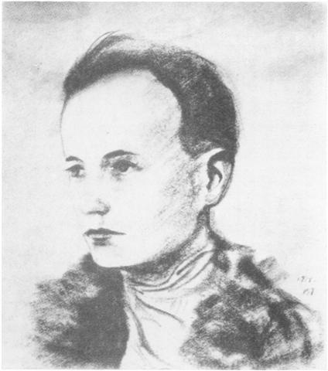

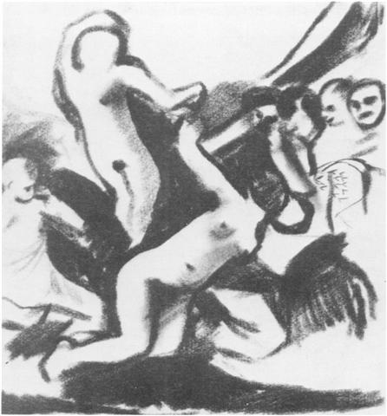
Fig. 1. Self-portrait, graphite, 21.5 x 19.0 cm, 1918. (Tretyakov Gallery.)

According to Zhegin, Chekrygin meant by this that the fresco is able to express different temporal and spatial conditions. As a form, the fresco is extended and can assume a multiple viewpoint and slow the passing of time so that several moments may be shown simultaneously. The fresco is essentially synthetic in character.
Chekrygin was enthusiastic about-almost obsessed by-the utopian ideas of Russian philosopher Nikolay Fedorov (1828- 1903). Fedorov's book The Philosophy of the Common Cause ("Filosofia obshchego dela") also had an extraordinary influence on Konstantin Tsiolkovsky (1857-1935) [6]. Like Fedorov, Chekrygin believed in the power of human reason, in a forthcoming grandiose development of science, which he was convinced would overcome death and resurrect those already dead, who would then dwell on other planets and in other galaxies. Chekrygin tried to express vision of a great future cosmic era for mankind through the images in his drawings, all in preparation for the grandiose fresco he was destined never to begin. Chekrygin dedicated to Fedorov's memory his tract "On the Art of the Future: Music, Painting, Sculpture, Architecture and the Word".
As early as 1918 Chekrygin began the cycle of drawings 'About Human kind', which later grew into the grandiose fresco projects for 'The Resurrection' (Fig. 2) and 'The Resettlement of People in the Cosmos'. All that remain are sketches in fragments of the composition, about 1500 works, of which most are drawings in charcoal, slate or sanguine pencil, and a few in colored chalk (see Fig. 3). Some of these are preserved in the Tretyakov Gallery and the Pushkin State Museum of Visual Arts or in family and private collections.
Chekrygin worked on other subjects, always dramatic in nature: rebellion (Figs 4 and 5) and the theme of the firing squad associated with it; 'Orgies', (Fig. 6) the original of which remained in Paris after the exhibition of 1928; and the theme that deeply moved him, starvation in the Volga Provinces, 'Mother and Child' (Fig. 7). Nevertheless, the basic task of the artist's brief life was and remained 'The Beginning of the Cosmic Era'.
As an artist and thinker, Chekrygin attempted to express his profound faith in the future regeneration of the world and his feeling for the essentially dramatic nature of life by conveying human feelings directly through drawing as if through music. The tense quality of his creativity is evident from his tremendous number of drawings, which contrast, some softly, some deeply and dramatically. His friend Zhegin maintained that his drawings were only graphic art by virtue of their material, but that in essence they were painting. One always accepts his drawings as though they were in color. This is perhaps particularly true of his romantic portraits, such as 'Lady in a Black Hat' 1922 (Fig. 8).
Chekrygin can hardly be compared to any of his contemporaries. Yet, in his cosmic images, he embodied more profoundly and boldly than any of his fellows the dramatic and emotional pathos of the difficult, transitional era they shared, as well as the dream of life's transformation on earth which inspired so many.
One-man exhibitions of V. N. Chekrygin's work have been held in 1923 in Moscow (catalogue and introductory article by A. Bakushinsky); in the Vladimir Mayakovsky State Library Museum in 1957 and in 1964; and in the A. S. Pushkin State Museum of Visual Arts in Moscow in 1969-1970 (illustrated catalogue compiled and introduced by E. Levitin and containing extracts from the memoirs S. F. Zhegin and B. Shaposhnikov).
The following sections are translations of Chekrygin's manifesto for the Makovets and excerpts from his diaries and letters.

'OUR PROLOGUE' BY VASILIY CHEKRYGIN [3]

The latest achievements of contemporary art have not gone beyond the stage of laboratory experiments on aspects of form. These experiments exhaust the strictly material potential of the professional craftsman (whether painter or writer), yet absolutely exclude the spiritual participation of the creative artist.
Fig. 2. Sketch for composition on the theme of the Resurrection, pressed charcoal, 31.5 x 28.3 cm, 1921.
(Pushkin Museum.)
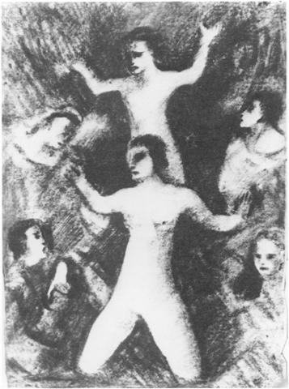
Fig. 3. Composition for the Resurrection Cycle, graphite, 28 x 22 cm, 1921.

In view of the total absence of a generally accepted artistic ideal, there has never been a stronger instinct to go one's own way as at the present time. This divisive individualism and artists' intensive work to invent some narrowly subjective means of expression have so possessed this group as to render them incapable of integrating the objective world with their own subjective understanding of it. Artists are forced to work out their own ultimate aims as well as the forms of their art. The results are products with the curious and ornate stamp of individual genius.
Attempts to produce curiously constructed forms within a chain of perceptions reached from an idiosyncratic viewpoint cannot be based on any sound artistic principle. Such attempts are the result of a subconscious current, which bears us along the line of least resistance to artistic activity that is expressionistic and yet totally anarchic, producing an illusion of consequentiality even where there is a total absence of principles founded on the real nature of art.
Artists have not proved capable of transcending that poverty of artistic content. They seek to fill it out with doctrinaire exaggeration or by a purely analytical approach or by individual interpretations of the unsatisfactory nature of their achievements. It is in contemplating such works of profound decadence and moral neglect that we come more clearly to perceive the firm foundation of the true, high and unshakable discipline of artistic thought.
We know that not every unfragmented and objective work of art presents the world as an inchoate mass of roughly shaped parts. On the contrary, every detail and phenomenon is influenced by a great linking force, a great law of cor- respondences. The eternal order reflected in all things indicates that their significance is infinite and unencompassable and illuminates the religious essence in the work of the true artist.
It is the duty of art-the repository of popular wisdom, rooted in the grey past-to prepare the way for individuals to express themselves through powerful, living images. Art should lead the people to a lofty cultivation of knowledge and feeling, involve them in active, creative thinking, and teach them a sense of values and judgement. Art should permeate life, lending it harmony and cohesiveness.
The achievement most worthy of human effort is objective, artistic, constructive work. If life and science are concerned with separate springs of being, then it is up to synthetic, objective art to draw from the welling cup into which both have emptied their waters.
Objectively, we experience the correspondence and connection between all things by imagining them in ways readily comprehensible to the human mind. Yet we are aware that only in its great objectivity does the image retain its full force, in spite of the fragmentation produced by the dark gropings of individual feeling. Our art proceeds from the passionate needs of the soul, which draws to itself and collects single rays of light that have been scattered by the reflecting prism of the contemporary mind.
We are assisting at the end of analytical art. Our present task is to collect its scattered elements into a mighty synthesis. Our assumption is that a renaissance in art is possible only if we strictly adhere to the heritage of great masters of the past, resurrecting all that was glorious and alive in their art. Our art proceeds not from inventive fantasy, nor from a concern for form alone, without which no artist can exist. We value the high sentiment that produces monumental art. We are aware that art becomes monumental only after it has attained the highest level of technical proficiency. It follows that our task is to transform feeling into visual perceptions, to establish the borderline between the material (form) and the spiritual (the feelings and experience of the artist).
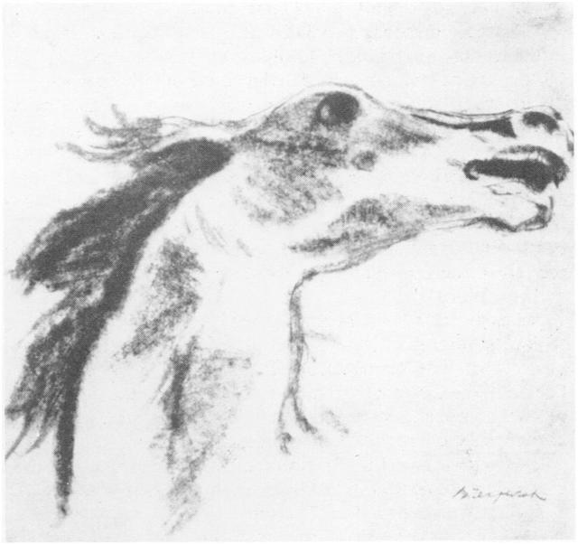
Fig. 4. Head of a stallion symbolizing revolution, graphite, 21.0 X 22.4 cm, 1920.

We do not feel nature as an environment. We know nature is that true state which reveals itself only to those with profound creative manifestations are related to our own. It is as though, coexisting with nature, we experience in ourselves the aspect of nature that is hidden from us. The task of our art is to bring harmony to the impulsive voices of nature as they rise into the spiritual sphere of being and to blend them into those powerful and whole images which synthesize all spheres.
If our image is perfect in clarity, then it will be not only a creative vision, to which we are striving to give real, translucent form, but it will serve as a true illumination of the spirit and of the heart of the whole contemporary world. What we see is no doubtful vision, but the true river of being. We feel that we, too, are born of this flood, that we are the sons of life as a whole, even as we are the sons of art as a whole.
Uniting in our feeling for life to produce a great, whole, monumental art-which would be quite beyond the capacity of isolated individuals-we intend to cultivate a spirit of community and firm tradition.
We are not against anybody. We are not out to set up any new 'ism'.
The time has come for enlightened work. There is a need for unshakable values. Art is being reborn within the endless process of its development. It requires only the simple wisdom of the inspired.
We believe that Russian art, like Russian thought, after passing through a great furnace of trials, will bring to the world the joy of purification. With faith, we continue on our way through life's vastness. We see ahead of us the mystery of images as radiant, resplendent reality.

EXCERPTS FROM THE DIARIES AND LETTERS OF V. N. CHEKRYGIN

Ilya Semenovich Ostroukhov once said to me that Andrey Rublev was remarkable for his sense of color in that he always found astonishingly unexpected combinations which, nevertheless, did not obtrude themselves but were permeated with a remarkable accord or harmony.
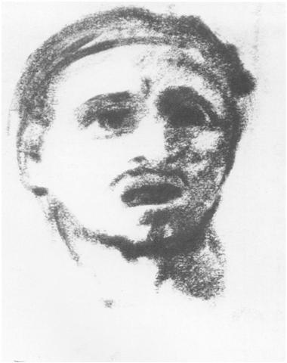
Fig. 5. Head of a slave, pressed charcoal, 22.2x 17.6cm, 1922
(Tretyakov Gallery.)
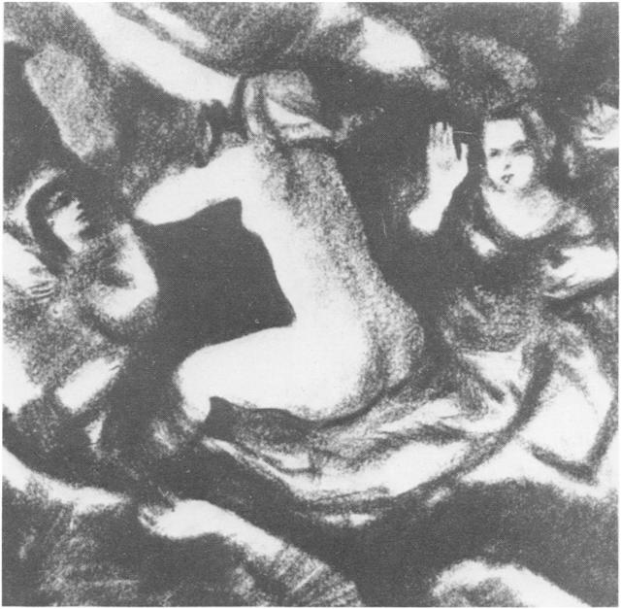
Fig. 6. Composition (possibly for 'Orgies') with semi-drapedfemale figure, pressed charcoal, 30.6 X 24.2 cm, 1921.

That is true. I know nothing loftier than Andrey Rublev as artist and painter.... I remember his Trinity, there are two light-blue forms in it, part of the robe of the central angel and on the right at the edge of the picture... another blue form. This position of the light-blue forms is crazily bold.... I have not seen such boldness in the work of the cubists or the suprematists....
Proletarian art ... is just as absurd as proletarian music or proletarian integral and differential reckoning [7]. [Diary entry, 25 January 1921] Easel painting is nothing but a fragment of the general tragedy of everyday existence, the only full expression of which can be the frescoe [8].
['Thoughts', 1 January 1921] It is painful to realize how we artists are bound by force of circumstance... to break up the general plan into small fragments in our drawings and sketches which will then be scattered and the general picture lost [9].
['Thoughts', 20 January 1921] (Of modern art) ... its methodology is exhausted, the possibilities which opened up the new methods of the new art, i.e. cubism, the building or invention of futurism, etc. Their methods are so constricting, that they did not leave that minimal freedom to the creative artist without which, essentially speaking, the genuine creative act is unthinkable....
The time of stress and show-off hooliganism is over, there is no face to slap, or, more exactly, in dealing out slaps we only hit ourselves....
Nobody can force an artist to accept a method that is false. Picasso's palette is cubism, Malevich's palette is suprematism, but neither the one nor the other represents the one and only artistic truth, in the face of which everything else is error and what went before nothing but forerunners. That is false. There is only one truth, the nature of painting, its own strict principles which may not be flouted without destroying painting itself.... [10]
['Thoughts', 20 January 1921] The wise old saying "be true to nature" means: be true to the nature of that art from which you are making those images which surpass images, "which stand in Nature on the way of intent" (Goethe), which are images of the ideal.... Nature has brought forth something more subtle than itself-man. Man has become an artist. Through the artist, nature has brought forth images beyond its own power to produce. The artist is above nature. He resurrects. The past, present and future are blended into one.... [11]
['Thoughts', 20 January 1921] I am one of the first Russian students of futurism. The legendary Marinetti invited me to his home in 1914. I tell you this in order that you should understand my attitude to the new movement. But it was not long before I broke with futurism, because I saw that it lacked firm foundations and I could not build my attitude to the world on a basis of sheer equine emotionalism.
Italian futurism is a typical impressionistic-emotional way of reacting to the world. It has not produced any method in art and is essentially so insignificant as scarcely to deserve serious consideration [12].
[From a letter to N. N. Panin, 6 December 1920]
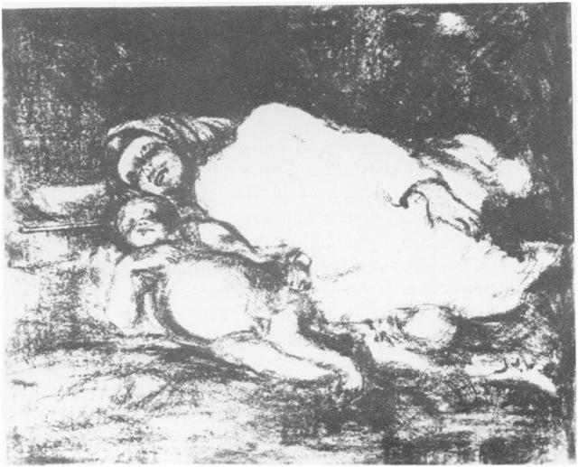
Fig. 7. 'Mother and Child', pressed charcoal, 24 x 29 cm, 1921-22.
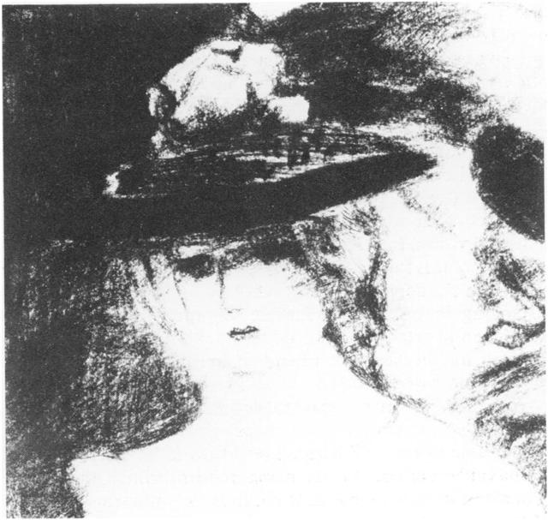
Fig. 8. 'Lady in a Black Hat', pressed charcoal, 24 x 24 cm, 1922.

REFERENCES AND NOTES
1. The first lithographed collection of Mayakovsky's poetry, Ya, Moscow, 1913, consisted of a cycle of four poems. Cf. the latest Soviet Collected Works: Vladimir Mayakovskiy, Sobranie Sochineniy v dvenatsati tomakh, 1, 13s-ro, Pravda, Moscow, 1978, pp. 76-78 and 408.
2. Aleksandr Blok's poem 'The Twelve' was written in January/ February 1918 and first published in the newspaper Znamya Truda (The Banner of Labour) 18 Feb./3 Mar. 1918 in Petrograd. Mayakovsky's wartime 'Chastushki' illustrated by Chekrygin were not published.
3. V. Chekrygin, "Nash Prolog", Makovets 1, 3-4 (1922).
4. V. Chekrygin, Makovets Zhurnal Iskusstv 2, 10-14 (1922).
5. The word used in Russian is not the modern 'ekzistensial'nyy' used to describe the philosophical trend, but the adjective 'bytiynyy' from the substantive 'bytiye', i.e. 'being'.
6. Fedorov's curious 'scientific religion' looked forward to a time when man would literally raise the dead and colonize the stars. Tsiolkovsky, who has been called the father of Russian rocketry, dreamt of contributing to Fedorov's 'common cause' through scientific invention, just as Chekrygin did through 'synthetic', 'theurgic' art. This projection of the dreamer and philosopher's thought into the work of the man of science on the one hand and, on the other, into Chekrygin's vision of a transformed humanity which would command cosmic space, is particularly characteristic of the Makovets group which refused to accept the concept of 'two cultures', seeking to work out ideas in terms of art, science and philosophy.
7. A. Molok and V. I. Kostin, "On the Idea of the Future Synthesis of the Living Arts", based on extracts from the letters of V. N. Chekrygin to N. N. Pavin, Sovetskoe Iskusstvoznanie, 1976, Vypusk 2 (Moscow: Sovetskiy Khudozhnik, 1977) p. 293. 8. Molok and Kostin [7] p. 296.
9. Molok and Kostin [7] p. 29.
10. Molok and Kostin [7] pp. 306-307.
11. Molok and Kostin [7] p. 308. 12. Molok and Kostin [7] pp. 310-311. 123

